Test Case: tc006_SPX_Dev5_Validacion_Boton_AddNewMenu_Administrador_Menu
Step 1 - Enter username and password and click to button Enter : Credentials Entered
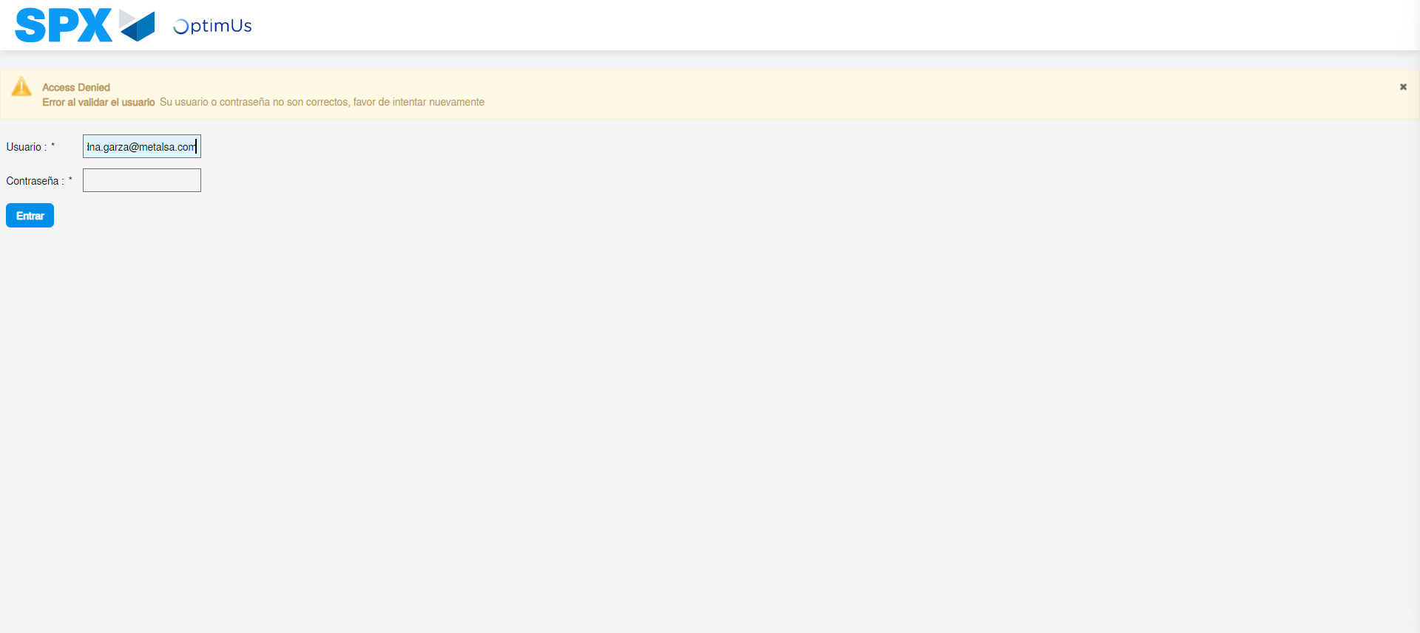Image file-name: QC_Testing-tc006_SPX_Dev5_Validacion_Boton_AddNewMenu_Administrador_Menu-may. 15 2024, 01 02 04 p. m.

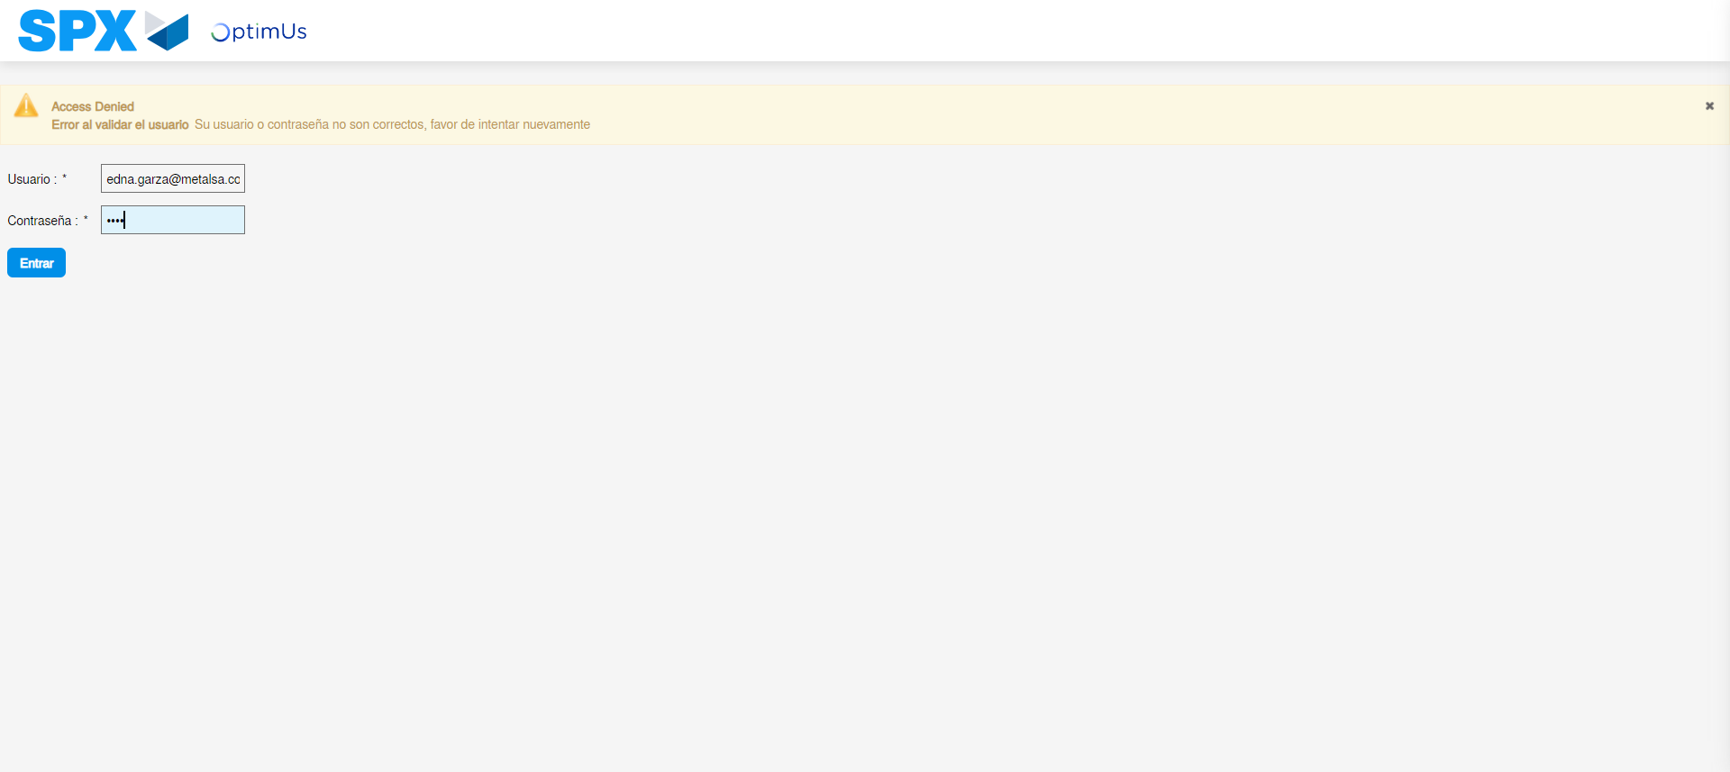Image file-name: QC_Testing-tc006_SPX_Dev5_Validacion_Boton_AddNewMenu_Administrador_Menu-may. 15 2024, 01 02 05 p. m.

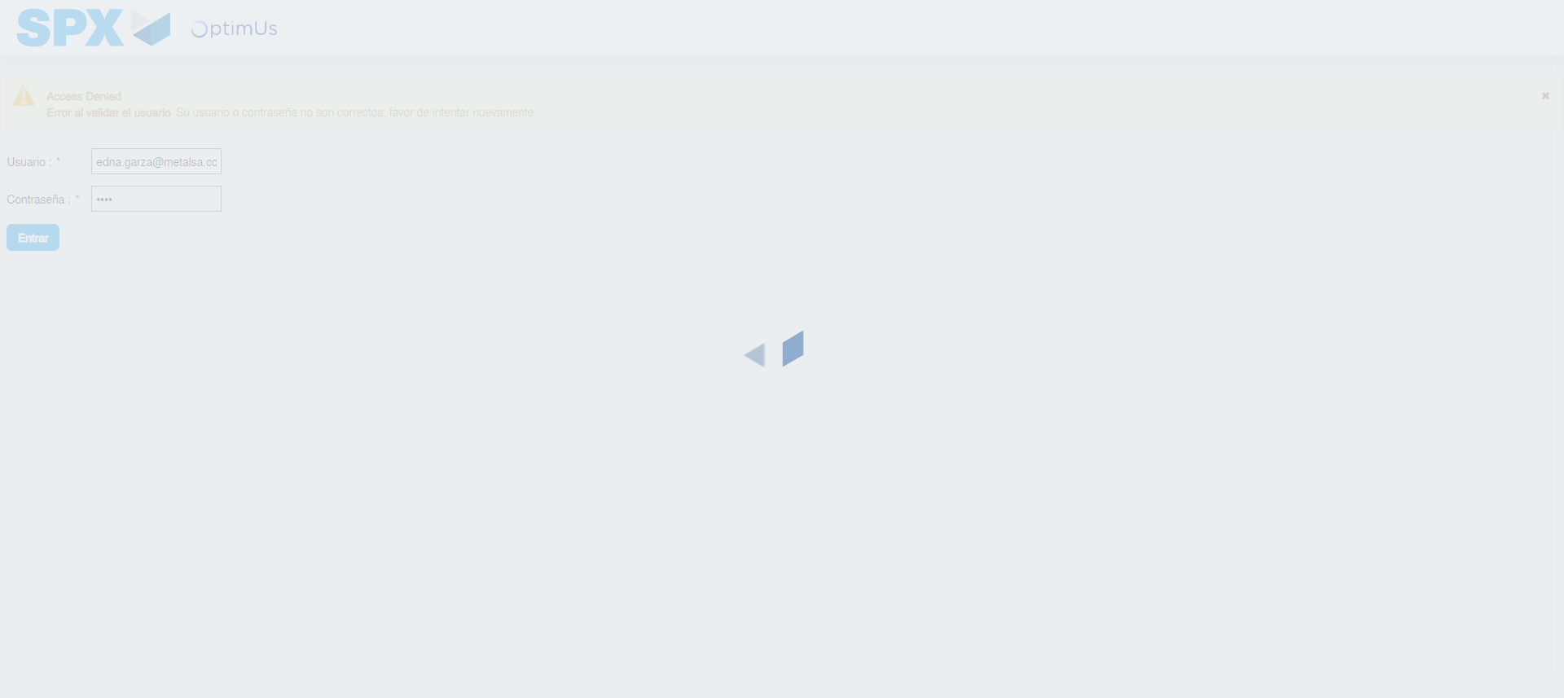Image file-name: QC_Testing-tc006_SPX_Dev5_Validacion_Boton_AddNewMenu_Administrador_Menu-may. 15 2024, 01 02 06 p. m.

Step 2 - Select to UEN and Access to Administrador Roles Menu: UEN Correctly selected and Correct access
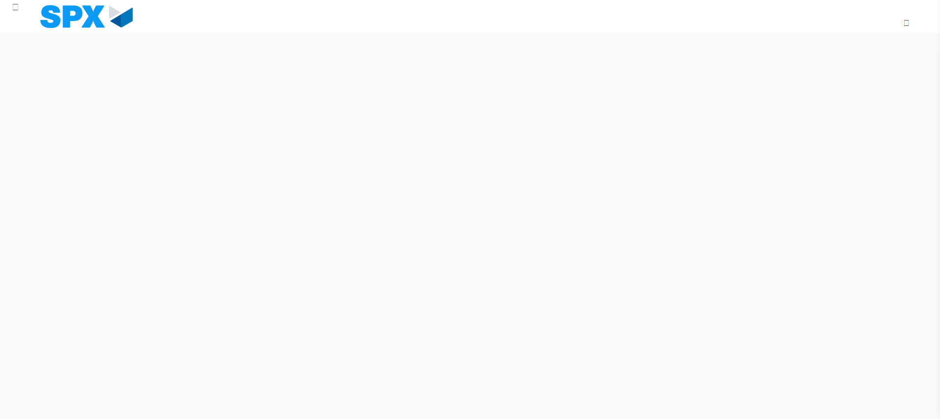Image file-name: QC_Testing-tc006_SPX_Dev5_Validacion_Boton_AddNewMenu_Administrador_Menu-may. 15 2024, 01 02 10 p. m.

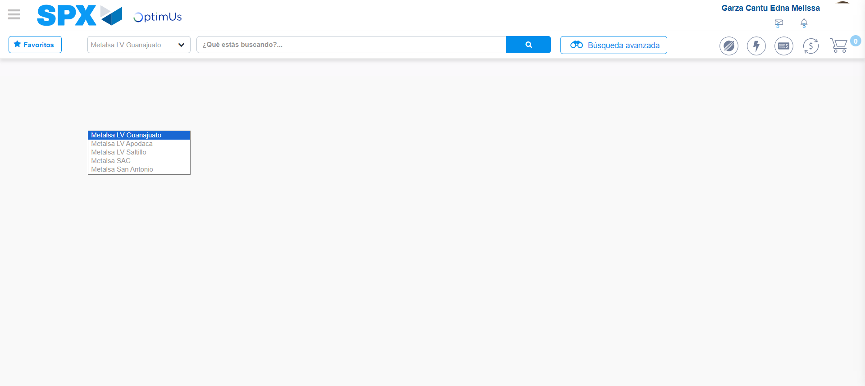Image file-name: QC_Testing-tc006_SPX_Dev5_Validacion_Boton_AddNewMenu_Administrador_Menu-may. 15 2024, 01 02 11 p. m.

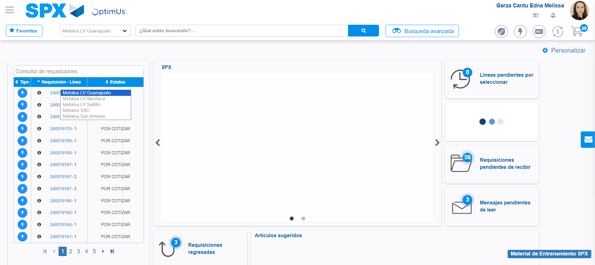Image file-name: QC_Testing-tc006_SPX_Dev5_Validacion_Boton_AddNewMenu_Administrador_Menu-may. 15 2024, 01 02 12 p. m.

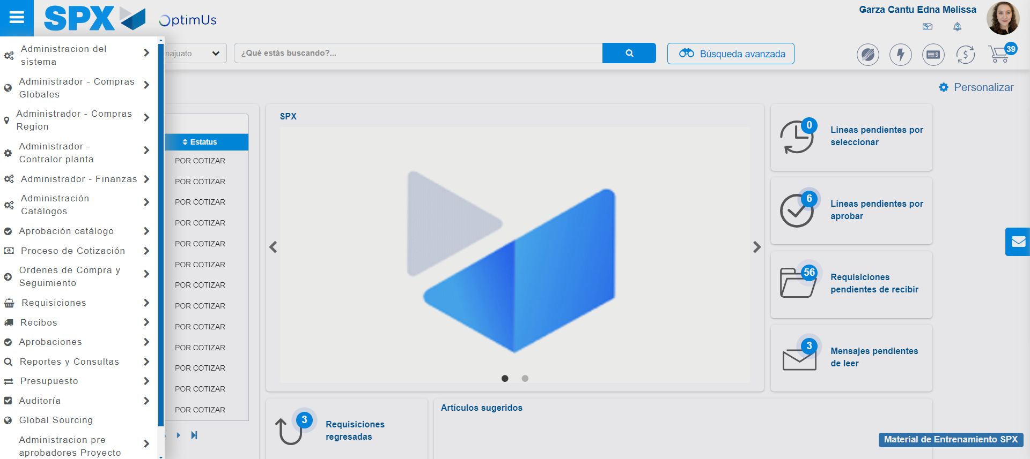Image file-name: QC_Testing-tc006_SPX_Dev5_Validacion_Boton_AddNewMenu_Administrador_Menu-may. 15 2024, 01 02 13 p. m.

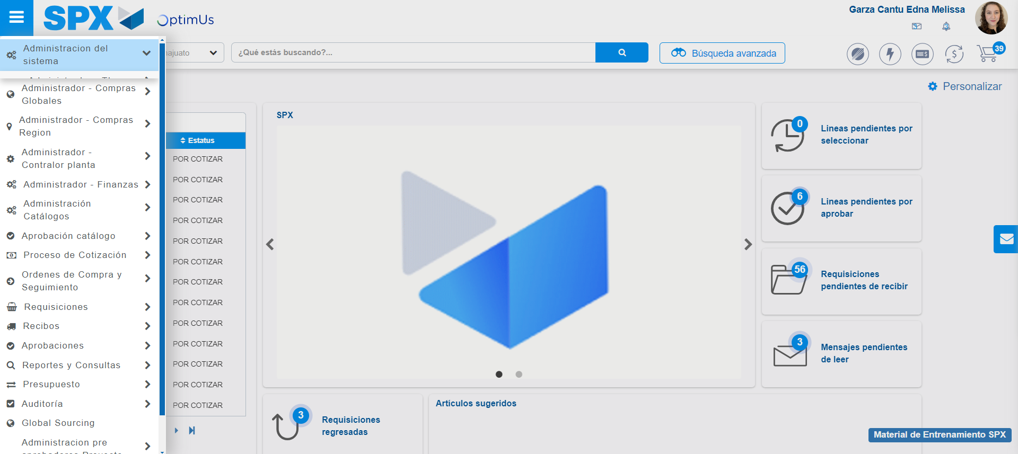Image file-name: QC_Testing-tc006_SPX_Dev5_Validacion_Boton_AddNewMenu_Administrador_Menu-may. 15 2024, 01 02 14 p. m.

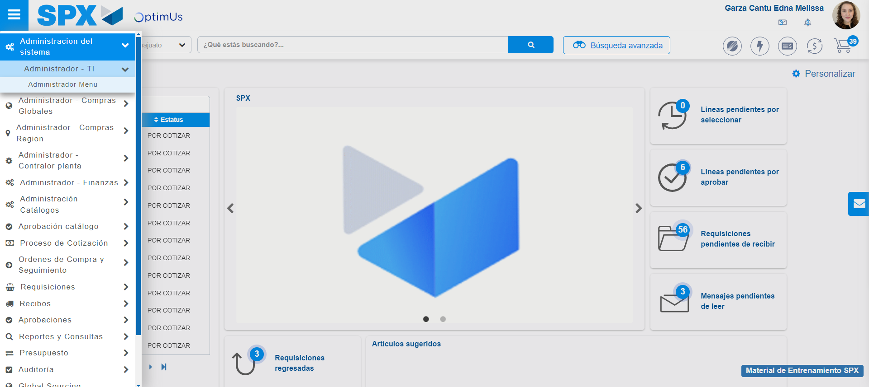Image file-name: QC_Testing-tc006_SPX_Dev5_Validacion_Boton_AddNewMenu_Administrador_Menu-may. 15 2024, 01 02 15 p. m.

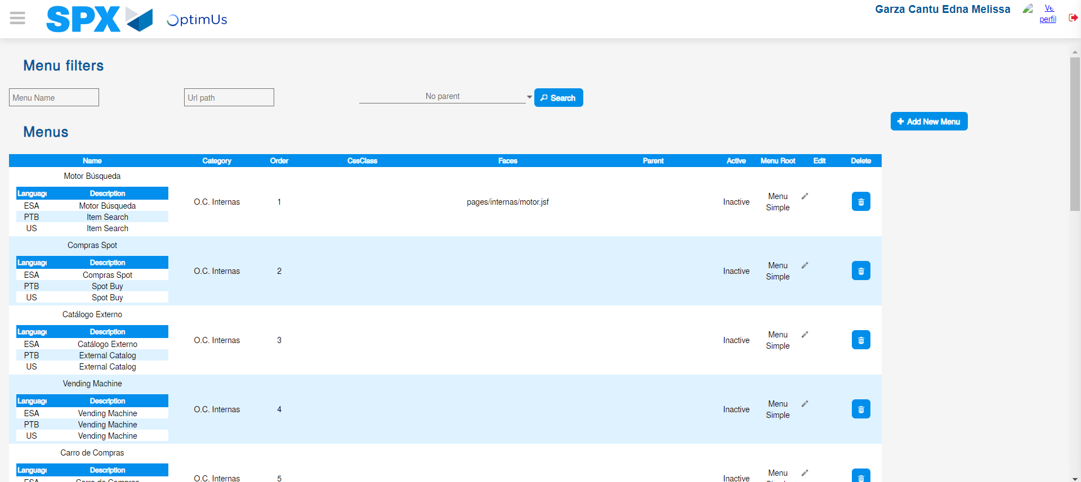Image file-name: QC_Testing-tc006_SPX_Dev5_Validacion_Boton_AddNewMenu_Administrador_Menu-may. 15 2024, 01 02 22 p. m.

Step 3 - Perform a search with the URL Path filter: Successful search
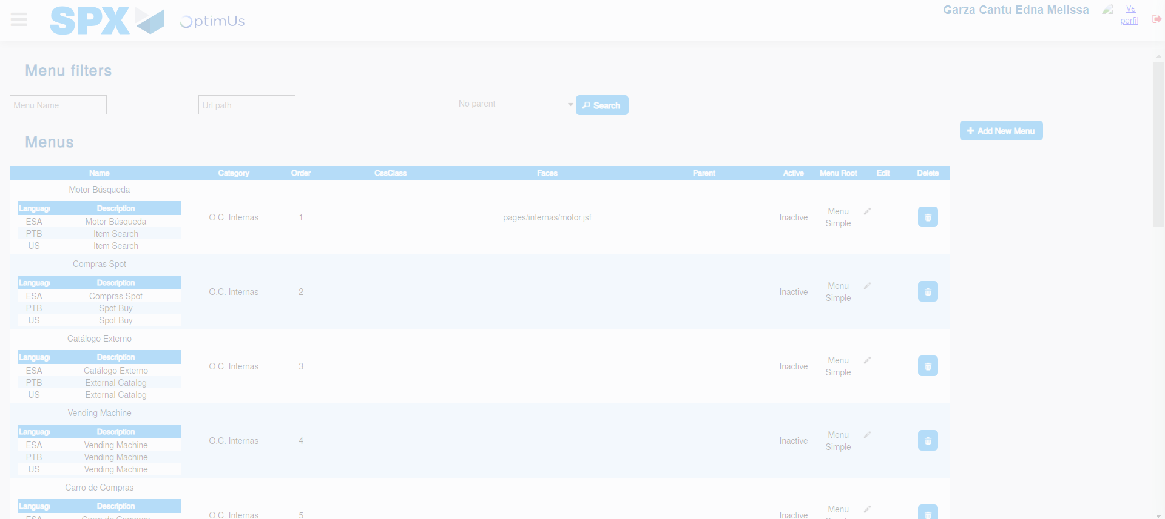Image file-name: QC_Testing-tc006_SPX_Dev5_Validacion_Boton_AddNewMenu_Administrador_Menu-may. 15 2024, 01 02 23 p. m.

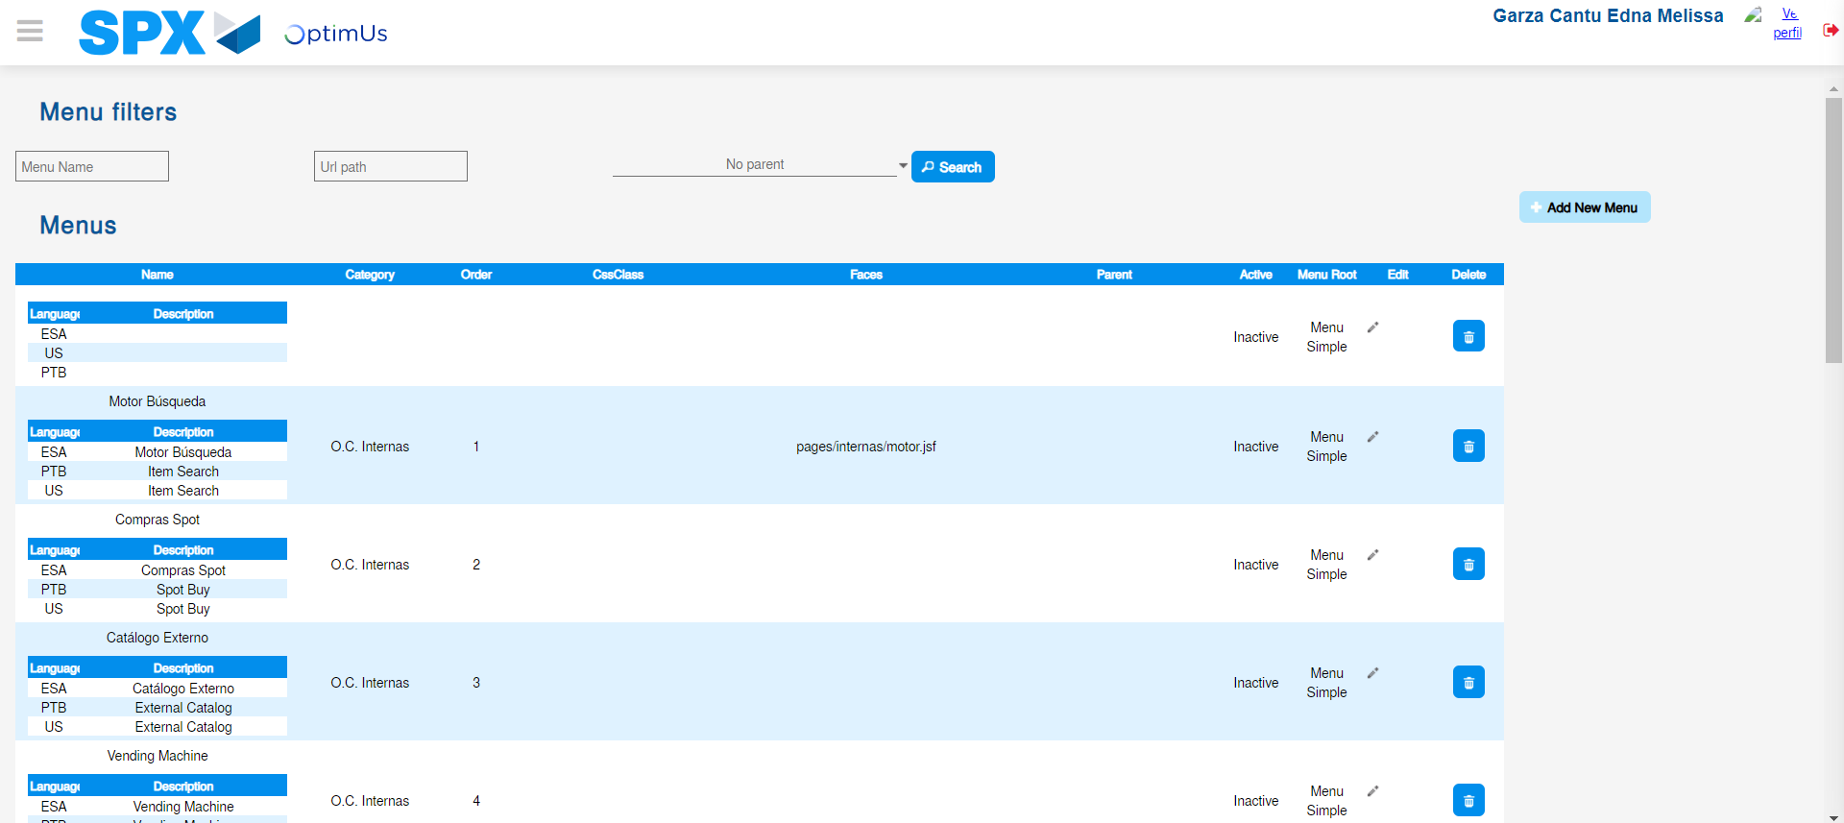Image file-name: QC_Testing-tc006_SPX_Dev5_Validacion_Boton_AddNewMenu_Administrador_Menu-may. 15 2024, 01 02 27 p. m.

